- Should we raise the minimum wage to a living wage or universal basic income ?
There are significant disparities in income across the USA (and of course globally, but we’ll get to that after we cover social stratification in the USA). Please watch the following videos which visualize and discuss income inequality in the USA.

https://youtu.be/QPKKQnijnsM
https://youtu.be/-SCB1t28nDU

- What are your reactions to the videos?
- What do you think should be done about the minimum wage in relation to cost of living? Please explain your answer by developing your argument and provide a detailed response to this question. You can discuss Montgomery County specifically or use other examples across the country.
- Make sure to bring in sociological theories and concepts from the core and supplemental required materials.
For background information: the Fight for 15 campaign, among others, has been fighting to increase the minimum wage across the country.

- Addressing Social Inequality
Top of Form
- Watch the below videos of ways that individuals have addressed social inequality (gentrification, homelessness, court system disparities, food deserts) at the micro level.
- Choose one of the social issues and discuss macro level structural changes that could further address the social problem- BE SPECIFIC- simply saying "more money from the government" or "add a grocery store" are not sufficient answers.

https://youtu.be/n6h7fL22WCE
https://youtu.be/UYo9MAbaDRg
https://youtu.be/kQu-4kPiDjQ
https://youtu.be/PdRkqRTIj7I

Bottom of Form

- Essential Workers in a Pandemic

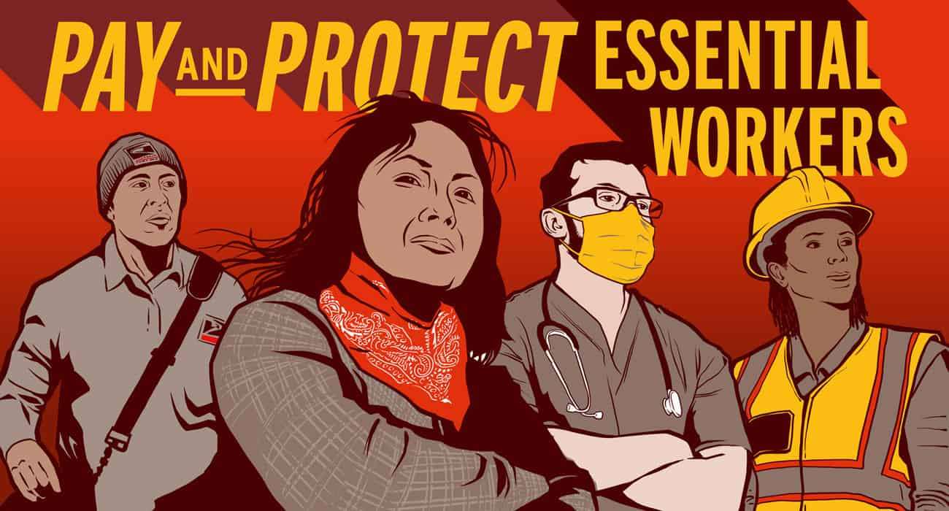
Sociologists theorize about the causes and justifications of inequalities in our societies. Functionalists, conflict theorists, and symbolic interactionists, take vastly different approaches to these issues. As we are increasingly seeing, the COVID-19 pandemic of 2020 has really emphasized the stark inequalities that exist in the United States.
https://youtu.be/VCnBgaGJMKc
https://youtu.be/1Zgmn9g5i-s
- Watch the two videos above and discuss at least two different forms of existing inequalities that have been amplified by the pandemic.
- What new inequalities can you identify as emerging as a result of the COVID-19 pandemic?
- Which theoretical approach do you think is best suited to understand this situation and the treatment of essential workers pre and post COVID-19? Explain your answer using sociological concepts and theories from the module materials.

- Financial Tips & Tools
- Review the financial information and tools that interest you.
- Discuss how you can utilize and/or apply them in your own life.
- Create a simple pledge to yourself of 1-2 tangible things you can do to improve your finances. These should be concrete actions you can implement now. *You do not need to share specific details of your finances in your post or pledge.Share only what you are comfortable with.
Free Annual Credit Report
This link takes you to your free credit report. There are three companies that provide you with reports. You can check all three reports at the same time or check 1 every 3-4 months so that you are able to view throughout the year. This is not a credit score, but these things can affect your credit score so you want to check for any inaccuracies.
Credit Scores and Credit Reports 101
https://youtu.be/71iaNlskCc0

Wealth Calculator
"How much money could you have? Use our wealth calculator to see if you’re on track for your major savings goals. Our calculator estimates your potential gains for investing in the stock market versus other avenues. In fact, you can use the calculator to plan for retirement or other major life event."
Tools for Overcoming Generational Poverty
"One of the growing concerns in the United States today is the paycheck-to-paycheck cycle and generational poverty. Systemic issues continue to throw up barriers, but it’s still possible to get ahead in your own finances and overcome generational poverty."
Maryland Net Pay Calculator
Have you ever wondered how much money you will take home after taxes, retirement contributions, and deductions for healthcare? Use this calculator when considering a new job to estimate how much of your salary you will have left after taxes and deductions.
Credit Card Calculator
Use this calculator to see how long it will take you to payoff a credit card paying a certain monthly amount or to see how much you should pay each month to pay it off within a certain amount of time. You can find the APR (annual percentage rate) on your monthly billing statements.
Credit Card Tips
Tip 1: If you generally pay your card/bills on time and are late, most companies forgive 1 late fee a year if you call and ask for it to be removed.
Tip 2: If you accept a promotional APR (e.g. zero payments for 6 months) and do not payoff the ENTIRE loan before the promotion expires, the company will go back and add 6 months of interest at their standard APR rate, which is usually very high 20%+, to your remaining balance.
Tip 3: Carecredit is a credit card specifically for dental, medical, and veterinary care. They frequently offer 0% interest for 6-12 months, but very high rate of interest that will be added on if you do not pay off your balance before the promotion expires.
Tip 4: Sometimes when you have many high interest credit cards/loans it may be in your best interest to consolidate them. While there is a loan consolidation fee added to the loan, this can be a way to make one payment at a lower interest rate and payoff your debt faster. Upstart is a loan consolidation company that unlike many consolidation companies, takes a more holistic look at your financial situation to include your education.
Tip 5: There are many methods to payoff debt. One is to payoff the debt with the highest interest rate; however, some people get discouraged when this takes a long time and give up. A popular method due to the feeling of reaching goals faster is the snowball method where you begin by paying off your smallest debt first.
Tip 6: Consider using a credit card at stores, restaurants, and for online shopping (that you payoff monthly) instead of a debit card. If your card is stolen it is often more of a hardship to have to wait for money to be put back into your bank account than to have a credit card company refund credit. You can also setup notifications for credit and debit cards to alert you when a certain amount posts (e.g. anything over $200) or when you are close to your credit limit to help catch any fraudulent activity.
Tip 7: Always setup a travel notification with your bank/credit cards to alert them when you will be traveling or out of the area so that they do not freeze your accounts.

- Unions
- View 1-2 of the following videos about unions OR do some research on your own about unions.
- Discuss what you learned using 2 key concepts (bold the concepts in your response) from this module. You may also share personal experiences.
- What are the pros (if any) of unions in your opinion? Are there cons in your opinion? Be very detailed in your responses.

https://youtu.be/yR7YT7sAZbY
https://youtu.be/nESQX_qTZzA
https://youtu.be/402m57yFjTM
https://youtu.be/ufpsxQwPP1Y

- The 1%
Watch the following videos about the wealthiest Americans. Discuss what you learned and/or your opinions using 2 key concepts (bold the concepts in your response) from this module.
https://youtu.be/9f82oMg6QRQ
https://youtu.be/JHPu0kCIXh0
https://youtu.be/j_m7Fia_v5A

